Document Reference & Name | : | American Express Enterprise-Wide  Customer Risk Rating (“CRR”) Methodology
Effective Date | : | September 30, 2021
Document Sponsor | : | Global Head of GFCC
Document Custodian | : | VP, GFCC Risk Management Office
Approval Requirement | : | Global Head of GFCC
Next Scheduled Review | : | September 30, 2022
No later than | : | November 30, 2022

Changes to Previous Policy:
- Further aligned Key Definitions of the CRR methodology with AEMP 04
- Expanded verbiage pertaining to the Risk Element score including overview of the setting of weightings and multipliers.
- Expanded verbiage for the process of calculating the customer risk score.
- Replaced the specific risk elements, listed in the risk categories section, with the data points that are available to be setup. The specific risk elements with risk rules are in the CRR Scoring Matrix which is an appendix document.
- Added CRR Customization details were updated to provide additional clarity.

Table of Contents
1 OVERVIEW AND PURPOSE 4
2 SCOPE 4
3 KEY DEFINITIONS 5
4 ROLES AND RESPONSIBILITIES 5
5 METHODOLOGY REQUIREMENTS 6
5.1 Introduction 6
5.2 Methodology 7
5.2.1 Risk Element Score 7
5.2.2 Risk Category Score 8
5.2.3 Customer Risk Score and Rating 9
5.3 AML Risk Categories and Risk Elements 10
5.3.1 Products and Services Risk 10
5.3.2 Customer Risk 11
5.3.3 Geography Risk 11
5.3.4 Transaction Risk 12
5.3.5 Additional Risk Factor and High Risk Overrides 13
5.4 Customer Risk Score and Rating 13
5.4.1 System Calculated Customer Risk Score 13
5.4.2 Mitigated Customer Risk Score 13
5.4.3 Customer Risk Rating 14
5.4.4 Customer Rescore Frequency 14
5.5 CRR Customization 14
6 EXCEPTION / CONFLICT / INTERPRETATION RESOLUTION 15
7 PROCEDURES APPROVAL REQUIREMENTS 15
8 ENFORCEMENT 15
9 RELATED POLICIES, REGULATORY GUIDELINES, AND SUPPORTING DOCUMENTS 16
10 REVISION HISTORY 16
11 APPENDICES 17
11.1 Appendix A – Reference Documentation 17

OVERVIEW AND PURPOSE
Customer risk rating (“CRR”) is a cornerstone of American Express Company’s and its subsidiaries’ (collectively, “AXP” or the “Company”) risk-based Anti-Money Laundering (“AML”) Compliance Program. Risk rating of its customers allows the Company to classify its client base according to the money laundering and/or terrorist financing risk that it potentially poses. It will assist in implementation of an effective risk-based program and enable AXP to better allocate resources to focus on and monitor higher risk clients.
The CRR methodology will facilitate decisions to:
- determine level of client due diligence;
- determine frequency of Know Your Customer (“KYC”) refresh or periodic review; and
- limit, or exit relationships.
Per AXP’s global standards and policies and as outlined in the Federal Financial Institutions Examination Council (“FFIEC”) BSA / AML Examination Manual, the CRR methodology takes into consideration data elements such as client type, ownership structure, product/service, and geography to help quantify potential risk for money laundering and/or terrorist financing. The identification of the CRR Methodology is based on AXP’s understanding of regulatory requirements, regulatory expectations, and industry guidance.
The Customer Risk Rating (“CRR”) is an enterprise-wide process and applies to AXP products / Business Units, both within the United States and in foreign jurisdictions. The intent is to ensure that the CRR for the Company’s accounts are identified in a consistent and quantifiable manner across the enterprise.
This document (the “CRR Methodology”) describes AXP’s framework and methodology for conducting the enterprise wide CRR.

SCOPE
The purpose of the Customer Risk Rating Methodology is to ensure customers and/or accounts maintained by American Express have an appropriate rating of money laundering and terrorist financing risk. Even though CADENCE is the enterprise money laundering risk rating solution, not every market and/or line of business is required to use it as long as they have a process to assess the money laundering risk. This situation must be approved by the GFCC RMO VP to ensure that adequate assessment of risk is performed.
Currently the following products are assessed outside of CADENCE:
- Thailand Consumer Charge Cards
- Thailand Small Business Cards
- CRA Loans / Grants / Investments
- Business Collateral CDs
The Customer Risk Rating will be performed for AXP across its Business Units and/or Legal Entities.

KEY DEFINITIONS
The following definitions are relevant to this methodology

- Money Laundering is a process that takes illegally obtained funds (for example, money derived from drug sales, theft, organized crime activities, embezzlement, among others) and puts them through a cycle of transactions or events, intended to make the money appear to be from legitimate sources. The act of money laundering conceals or disguises the nature or the source of the funds derived from illegal activities.
Generally, the money laundering process involves three stages:
- Placement is physically disposing of funds derived from illegal activity. Methods to accomplish this include depositing the criminal proceeds into bank accounts, placing the funds with non-bank financial institutions, such as currency exchanges, casinos, or check-cashing services, or using the funds to reduce or eliminate debt, such as using ill-gotten cash to make credit card payments.
- Layering is separating the proceeds of the criminal activity from the source through the use of layers of financial transactions. These layers are designed to complicate the audit trail, disguise the origin of funds, and provide anonymity. Examples of layering include the purchase of travelers cheques, which are then used to acquire goods or services, or the payment of funds to create a credit balance on a charge or credit card and then requesting a refund check.
- Integration is placing the laundered proceeds back into the economy in such a way that the money appears to re-enter the financial system as legitimate funds.
A financial institution may be used at any point in the money laundering process. AXP and its businesses must protect themselves from being used by criminals engaged in placement, layering, or integration of illegally derived proceeds.
- Terrorist Financing is the process by which terrorists fund their operations in order to carry out acts of terrorism. While many similarities exist between terrorist financing and money laundering, terrorist organizations often raise funds through legitimate enterprise; however, traditional money laundering always begins with criminal activity.
Common methods used to fund terrorist groups include making donations (often cross-border) to charitable or non-profit organizations; moving funds through unlicensed money transmitters; leveraging third-party service providers such as payment processors or crowdfunding platforms; the use of virtual or digital currency, and through accounts controlled by unknown beneficial owners.
- Customer Risk Rating (“CRR”) uses a quantitative process to determine the inherent risk rating of AXP customers and/or accounts. The inherent risk rating is based on risk elements, including account demographics (e.g. product/service risk, type of relationship, channel, structure, industry, and geography data), transactions and other criteria forming additional risk factors or high risk overrides.
- High Risk Override (“HRO”) High Risk Overrides when present adjust the Customer Risk Rating score to high risk (numerical risk score of nine).
- Additional Risk Factors ("ARF") are combination of data specific elements that identify unique risks. These apply points at either a Low, Medium, or High level which is intended to elevate the resulting risk rating
- Fundamental Assessments are the underlying assessment of data elements used in the CRR. These data elements include product/service, structure, acquisition channel, industry and geographic risk. These risk factors are updated from authoritative guidance and internal knowledge, and reviewed as necessary, at least on an annual basis. Updates and changes will lead to a risk re-score for all customers and/or accounts.
- Risk Categories are broad categories of risk faced by an organization including products and services, customers, transactions, and geographies.
- Risk Elements are the underlying causes or circumstances that lead to potential money laundering risk.

ROLES AND RESPONSIBILITIES
This Section sets forth the roles and responsibilities of relevant parties in managing the Company’s Customer Risk Ratings under this Methodology.
The Board of Directors of AXP and sub-committees thereof (the “AXP Board”), is responsible for the annual approval of the Global Anti-Money Laundering Policy that governs this Methodology. The AXP Board also reviews periodic reports regarding CRR, as appropriate.
The AML Risk Management Committee (the “AML RMC”) reviews periodic reports regarding Customer Risk Ratings and may directly escalate the review of Customer Risk Rating matters and reports to the Compliance Risk Management Committee (the “CRMC”) and subsequently to the Enterprise Risk Management Committee (“ERMC”) and the AXP Board.
The Compliance Change Management Committee is a sub-committee of the CRMC comprised of senior compliance leaders and provides oversight of compliance-related change management and a forum to discuss Compliance Program matters.
Global Compliance & Ethics is responsible for establishing, executing, and overseeing the Customer Risk Rating process as follows:
- The AXP Deputy Chief Compliance Officer & Global Head of AML, who provides oversight of the coordination of the anti-money laundering compliance programs of AXP businesses globally, including the Customer Risk Rating process and may escalate Customer Risk Rating matters to the ERMC, AXP Board, or other functional and senior management committees across the Company, as appropriate;
- The Global Financial Crimes Compliance (“GFCC”) Risk Management Office (the “GFCC RMO”), has primary responsibility for the following aspects of the CRR, including methodology development, maintenance, and updates to the CRR configurations.
Where applicable, the appropriate Line of Business Compliance Officer (“LOBCO”) (or his/her designees) will be requested to provide both quantitative and other qualitative data input for assessment of inherent AML risk. GFCC RMO will initiate and coordinate the process for collecting this information; review and assess the quality and completeness of this information; and be responsible for the usage of this information within the CRR process.
- The Global Financial Crimes Compliance International Oversight Teams (the “GFCC International Oversight”), are provided with the results of the fundamental assessments and provide any additional recommendations. The GFCC International Oversight teams are regional and work with the Market Compliance Officers for alignment.
- Line of business, market, legal entity, and staff group with AML responsibilities, are responsible for execution, support, and reporting and analysis relating to the Customer Risk Rating process. For their respective Business Unit, Line of Business Compliance Officers ("LOBCO") are the responsible group. For Legal Entity or market, the Market Compliance Officer ("MCO") or AML Officer is the responsible group. It is the responsibility of the LOBCO/MCO/AML Officer to share with management and business units the results and relevant risks from the CRR;
- Compliance subject matter expert staff (“Compliance SMEs”), individually or as a group serve as subject matter experts in a specific area of compliance for the Company and are responsible for providing support, reporting, and analysis relating to the Customer Risk Rating process for the areas of money laundering risk that they oversee. These responsibilities include providing support to the GFCC RMO in the determination of Inherent Risk within the scope of their specialized area.

METHODOLOGY REQUIREMENTS

Introduction
The CRR Methodology uses various factors to assess the money laundering and terrorist financing risk. The methodology incorporates customer demographic data, product and service inherent risk, transaction activity, and events to calculate the money laundering and terrorist financing risks of the customer. These data elements are defined in the Risk Categories and Risk Elements section of this methodology. The CRR Methodology is designed to provide a risk score for each customer and/or account maintained by American Express.

Methodology
The Customer Risk Rating is calculated based on the risk elements that are associated with the customer.
These risk elements are grouped into five risk categories:
- Products and Services
- Customer
- Geography
- Transaction
- Additional Risk Factors and High Risk Overrides
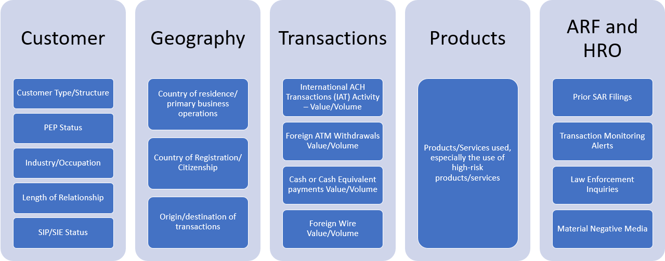
The listed risk elements are samples. The full list is on the CRR Scoring Matrix
Each risk element is assigned a score based on an analysis of its risk. The risk elements are then added together to create the score for each risk category. The risk category scores are then added together to create the customer risk score.

Risk Element Score
The CRR utilizes a strategy that allows a single assessment to work for different product types within the same thresholds of normalization from overall points to the 1 through 9 risk score scale. The key to this is the separation of base information, such as demographics, length of relationship, number of accounts etc., from the way the product can be used and how the customer uses products features.
The base information is the same for all product types and is based on the data available when the customer is acquired. The only variance in initial risk elements is the multiplier assigned to the product risk element. Each product is assigned an inherent risk score through the fundamental assessment process. The inherent risk is a score between 1 and 9. This inherent product score is used as the multiplier in the product/service risk element calculation. Some products/services such as merchants are low risk and have a low inherent risk score. Other products such as foreign exchange/international payments have a high inherent risk score. This results in higher risk products having a higher baseline risk.
Each product has features that serve as risk elements and can be used to build on this baseline risk. For example, credit cards have many types of transactions that can be monitored for patterns that are beyond the expected behavior for the portfolio. Other products such as merchants have less factors, as settlement is the only transaction performed by that portfolio.
The overall thresholds and individual weightings are carefully balanced so that different products can make use of the same assessment using the differing risk elements that are available. The key to this is understanding how each risk element is calibrated against each other element. Products with less opportunity for money laundering or terrorist financing will accordingly have less available risk elements and will tend to remain at lower risk levels.
A risk element is a combination of rules with a combination of data element criteria. This provides the flexibility to identify specific situations or red flags that identify money laundering and/or terrorist financing risks. The risk element score is determined by two parts, the Weighting Value and the Multiplier.
- The Weighting Value defines the risk weighting of the element and is definable at the market level.
  - All risk elements, regardless of risk category, are scored on a similar scale to ensure a balance for risk assessment. Setting the weighting value is based on the multiplier type and the potential maximum risk element score. Weighting scores are set to ensure that a single risk element doesn't influence the customer/account risk score too heavily, unless specifically intended due to regulation or industry best practices.
  - These weighting values are the same for all products. For example, the geography risk elements are viewed as the same risk level for a consumer, business, or merchant.
  - LOBCOs/MCOs can override the weighting value to ensure compliance to local regulations. This is done utilizing the CRR customization processes in section 5.5 of this document.
- The Multiplier is assigned based on criteria specific to the element called rule sets. Each rule set has rule(s) to identify the level of risk. When a rule set is true, the Multiplier is set to the number associated with the rule set. In situations where more than one rule set is true, a precedence for each risk element determines if the higher or lower multiplier will be used.
  - Fundamental Assessment: Fundamental Assessments are performed at an enterprise level to set the risk ratings for certain risk elements. These fundamental assessments are reviewed annually by the GFCC RMO following the Fundamental Assessment Procedure. Fundamental assessments are performed for the following risk elements:
    - Acquisition Channel
    - Geography
    - Industry
    - Products and Services
    - Structure
These enterprise fundamental assessment results are reviewed and approved by the GFCC RMO VP. MCOs can request overrides of the risk rating associated with a fundamental assessment to ensure compliance to local regulations. This is done utilizing the CRR customization processes in section 5.5 of this document.
  - Transaction Data: Based on transaction volume and/or value for a given range of time.
    - The ranges for the transaction based multipliers have been determined based on a review of the historic data, where transaction counts and amounts comprising the highest 20% of transaction types are analyzed to determine the appropriate ranges to identify the level of risk and set multiplier values for the group.
  - Element Specific: Specific situations that are associated with the customer (i.e., PEP, SIP)
  - Event Based: When events occur and frequency (i.e., SAR filed, Law enforcement inquiry, Transaction Monitoring alert)
The risk element score is the product of the Weighting Value multiplied by the Multiplier.

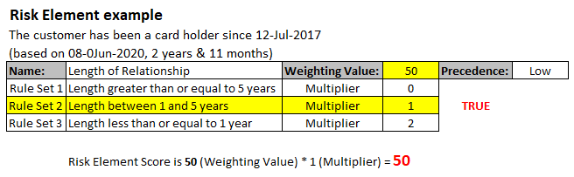

The CRR Scoring Matrix is a document that provides the details of the risk elements utilized to assess these risks for a customer. It also identifies if the risk element is applicable to money laundering (ML) and/or terrorist financing risk (TF). The ruleset(s) used to determine the level of impact are included. The following section provides the details of how these components are used to calculate the risk score of the customer.
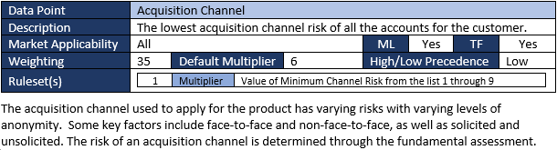
This an example of a risk elements from the CRR Scoring Matrix

A CRR Scoring Matrix is created at the enterprise level. A market level CRR Scoring Matrix is also created to provide details of customization that have been applied for local markets.

Risk Category Score
Each risk element is assigned to a single Risk Category to group the type of inherent risks. The Risk Category score is the sum of all risk element scores in that risk category. This grouping will identify the primary drivers of risk for a customer. There are five risk categories defined:
- Products and Services Risk
- Customer Risk
- Geography Risk
- Transaction Risk
- Additional Risk Factor and High Risk Overrides

Customer Risk Score and Rating
The Customer Risk Score is calculated based on the risk elements that are associated with the customer. While there are some risk elements that do not apply to all products, the balance of the risk element scores is set to ensure the higher risk customers are risk rated appropriately.
Risk elements and the associated risk score are identified for each active account for a customer, such that each account also has an account risk score. The customer risk score utilizes the appropriate risk scores from the risk elements for all active accounts. This ensures that the customer risk score includes a full scope of the risks presented by the customer.
The below example provides the process by which the Customer Risk Rating is determined.
Customer Risk Score – Active Accounts
This customer has two active accounts (Account 1 and Account 3):
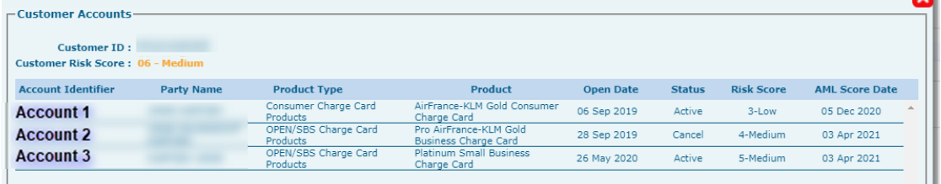
Account 1 (Risk Score of 03-Low) – Risk Elements
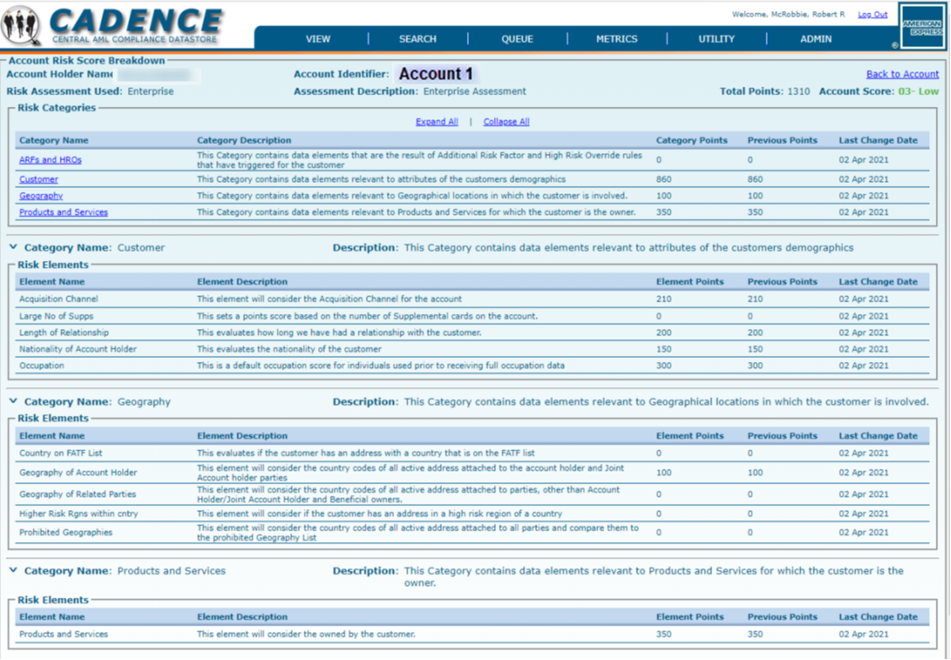
Account 3 (Risk Score of 05-Medium) – Risk Elements
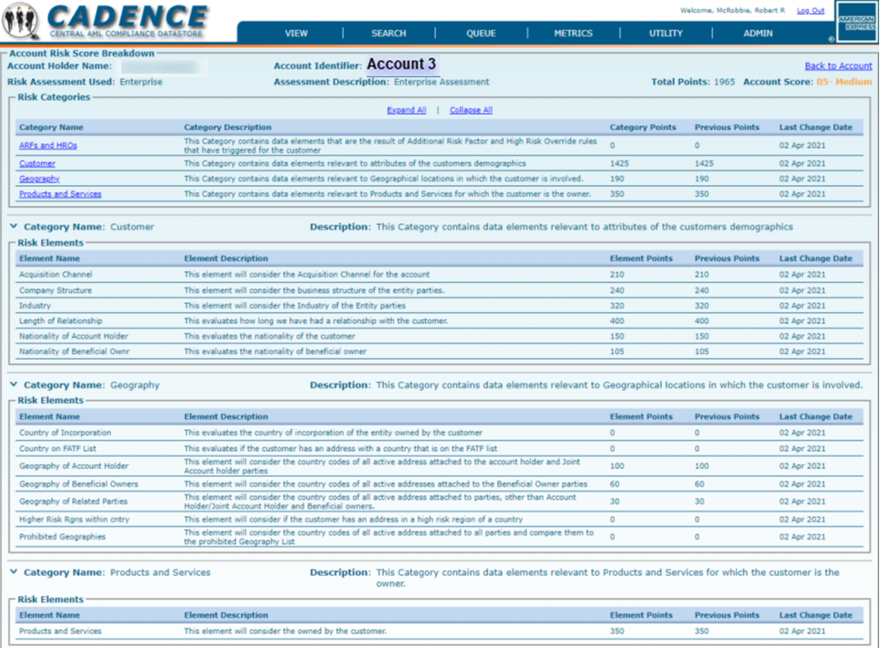
Customer Risk Score – Risk Elements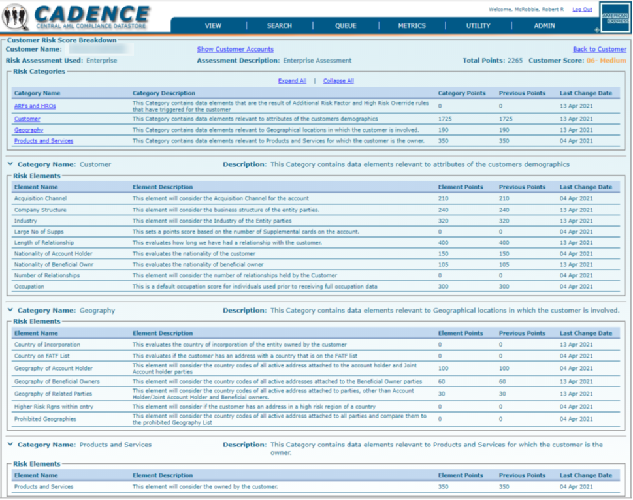
Category | Risk Element | Account 1 | Account 3 | Risk Points
Customer | Acquisition Channel | 210 | 210 | 210
Customer | Company Structure | 0 | 240 | 240
Customer | Industry | 0 | 320 | 320
Customer | Length of Relationship | 200 | 400 | 400
Customer | Nationality of Account Holder | 150 | 150 | 150
Customer | Nationality of Beneficial Owner | 0 | 105 | 105
Customer | Occupation | 300 | 0 | 300
Geography | Geography of Account Holder | 100 | 100 | 100
Geography | Geography of Beneficial Owner | 0 | 60 | 60
Geography | Geography of Related Parties | 0 | 30 | 30
Products | Products and Services | 350 | 350 | 350
Customer Risk Score |  | 1,310 | 1,965 | 2,265
Customer Risk Score - Risk Categories
The risk element risk points are then grouped by the risk category. This provides a quick reference to identify the categories that contain the primary drivers.
Category | Risk Points
Customer | 1,725
Geography | 190
Products and Services | 350
Transactions | 0
ARF and HRO | 0
Customer Risk Score | 2,265
Customer Risk Score – Risk Rating
The Customer Risk Rating is then determined based on thresholds for the customer risk score. The customer risk rating is standardized to the 1 to 10 scale. A score of 10 is assigned when a customer is identified as prohibited due to a sanctions related match to a prohibited geography or structure.
Risk Rating | Enterprise Threshold
 | Start >= | End <
01-Low | 0 | 700
02-Low | 701 | 1050
03-Low | 1051 | 1400
04-Medium | 1401 | 1750
05-Medium | 1751 | 2100
06-Medium | 2101 | 2450
07-High | 2451 | 2800
08-High | 2801 | 3150
09-High | 3151 | ∞

Risk Categories and Risk Elements

Products and Services Risk
Products and Services inherent risk is determined by evaluating potential risks (referred to as “risk areas”) associated with the core features of each product/service. The evaluation of the risk areas assesses whether the particular product/service provides for or allows the product to be used for the identified activities that could facilitate money laundering. The product and services inherent risk areas are:
- Cash or cash equivalent
- Anonymity
- Rapid transfer of value
- Large transfer of value
- Cross-border transfer of value
- Use by third parties
- Data quality (the quality of customer and transaction data available)
Identification of the product/service attributes against these risk areas provides a cumulative score that is the basis for determining the inherent risk score for each.
The scoring methodology assigns a point score to each level of risk within the area, with highest risk level receiving 20 points, medium risk level receiving 10 points and low risk level receiving 5 points. No points are assigned to nominal risk.
The points for each risk area are then summed together to determine the Products and Services risk score.
Risk Element | Description
Product/Service | The highest product/service risk score of all the accounts for the customer.

Customer Risk
Some customer types, industry types, and other customer demographic attributes can increase money laundering risk. For the purpose of assessing inherent money laundering risk of its customer base and business relationships, AXP considers the following data elements:

- Application's Channel
- Company Structure
- Nationality
- Income Type
- Industry (Entity)
- Length of Relationship
- Number of Accounts to Customer
- Number of Supplemental Accounts
- Occupation Industry (Individual)
- SIP / SIE
- PEP

Geography Risk
Potential money laundering and financing of terrorism risks presented by geographies are determined by an assessment of information that is objective and verifiable from authoritative sources, governmental agencies, as well as, international governmental bodies, such as the Financial Action Task Force (“FATF”).
The GFCC RMO also utilizes the Refinitiv World-Check Country Risk Ranking tool to assess the country risk ratings. The World-Check tool utilizes over 300 independent sources from more than 50 respected international organizations and think tanks to provide objective fact-based ranking. Some examples of these sources include: World Bank, FATF, World Economic Forum, OECD, European Union, United Nations, CIA – The World Factbook, and Transparency CPI.
The following data elements are available to assess for risk:
- Customer's country (to assess against Geography Risk and authoritative lists)
- Customer's postal code (to assess against higher risk postal codes, as identified)
- Customer's region (to assess against higher risk regions, as identified)

Transaction Risk
Potential money laundering and financing of terrorism risks presented by transactions are determined by an assessment of the types of transactions performed by a customer and if the transactions were domestic or foreign . Transactions are aggregated on a monthly basis, and the following data elements are used to assess transaction risk:
- Foreign or Domestic Transaction (based on issuing market of the account)
- Transaction Type (i.e., ATM Withdrawal, Payment-Cash, Payment-Wire, Payment-ACH)
- Origin / Destination Country of the Transactions
- Transaction Monthly Count
- Transaction Monthly Amount
- Transaction Monitoring Rules (Alert Type, Alert Triggered month, Number of Alerts)

Additional Risk Factor and High Risk Overrides
There are specific criteria where a customer must be considered high risk or have their risk elevated. These are addressed by High Risk Overrides (HRO) and Additional Risk Factors (ARF). The additional risk factors have three levels (High, Medium, and Low) to provide flexibility on varying risk points. Multiple HRO/ARF on a customer will be cumulative, where each will add risk points to the Customer Risk Score.
Risk Element | Description
High Risk Override | This element applies a weighting for each High Risk Override (HRO) that has triggered for the customer. When present, the customer will be assessed as high risk.
Additional Risk Factors  (Level 1, 2, or 3) | This element applies a weighting for each Additional Risk Factor that has triggered for the customer. The weighting is determined based on the level with the higher level receiving more points.  - Level 1 (formerly ARF+1)  - Level 2 (formerly ARF+2)  - Level 3 (formerly ARF+3)

Customer Risk Score and Rating
The Customer Risk Score and Rating can be set by two different methods,
- the System Calculated Customer Risk Score, or
- the Mitigated Customer Risk Score

System Calculated Customer Risk Score
The Customer Risk Score is calculated based on the sum of all risk element scores for the customer. The customer risk score is shown by the totals of each risk category to attempt to identify which category or categories are driving a higher risk rating. This is intended to identify the primary drivers of the higher risk.

Mitigated Customer Risk Score
When an Enhanced Due Diligence (EDD) review is performed, the customer's activity or information may be deemed to not be high risk. In these situations, the AML analyst can mitigate the risk rating to a lower rating as part of the closing of the EDD review.
When a customer's risk score has been manually reduced from high by an AML analyst after an EDD review is completed, there are situations where the risk rating would need to be set back to the system calculated score due to the identification of new information or new activity. The following three situations will override the mitigated risk rating.
Mitigated Risk Override | Reason
The system score increases by 15% or more of the high risk threshold | This allows any risk element to have the ability to raise the score again.
The system score decreases below the high risk threshold | The system score is aligned with a lower risk rating than requires an EDD
A new override HRO is added | If a new override is added other than the one that existed prior to the mitigation, there may be a need to review again.

Customer Risk Rating
The Customer Risk Rating is then determined based on thresholds for the customer risk score. The customer risk rating is standardized to the 1 to 10 scale with 1 to 3 being Low, 4 to 6 being Medium, 7 to 9 being High, and 10 being Prohibited.
LOW |  |  | MEDIUM |  |  | HIGH |  |  | PROHIBITED
1 | 2 | 3 | 4 | 5 | 6 | 7 | 8 | 9 | 10
This standardized rating groups customers to the basic levels of Low, Medium, High, or Prohibited, but also provides differentiation of three levels within Low, Medium, and High.

Customer Rescore Frequency
Customer rescoring occurs via two processes: 1) Every customer is rescored on a monthly basis to ensure that the data elements that are time-based are updated on a regular schedule; and 2) When changes occur in source systems, the updated information is fed to CADENCE, and the customer risk score is recalculated in the daily batch process.

CRR Customization
While risk elements are initially set with an enterprise weighting, adjustments to these weightings may be needed to align local markets to ensure compliance to local laws, regulations or regulatory expectations. This is accomplished through the CRR customization process:
- The initial engagement with a market will be the localization process.
  - The localization provides the opportunity to review the CRR for a market, and identify changes to weightings, threshold adjustments, and/or additional rules needed.
  - These changes will be applied within a sandbox to simulate and validate the results.
  - Once the sandbox results are validated, approvals are captured following the Change Management Control Process ("CMC Process") from the appropriate individuals.
    - The approvers will typically be the BSA/AML Officer or MCO, and if applicable, Legal Entity Representatives.
  - The sandbox is implemented to production with the adjustments that were made.
- The Customer Risk Rating Customization form
  - The Customer Risk Rating Customization form is used to request changes to the risk elements within the CRR. These changes include:
    - Fundamental assessment risk rating changes for a country
    - Weighting changes to existing risk elements
    - New risk elements to address regulatory expectations
  - The form is submitted to the GFCC Oversight team for review
    - The GFCC Oversight team will review the request with AML Officer/ MCO/ LOBCOs to ensure the form is completed correctly and the request is fully understood to address the need
  - The GFCC Oversight team then submits the form to the GFCC RMO
    - The GFCC RMO configures the requested change in the sandbox to perform the analysis on the impact to the customer population risk ratings
    - These results are then validated with the GFCC Oversight Team and the MCO/LOBCO to ensure the results meet expectations
  - When results are confirmed, approvals are captured following the CMC Process from the appropriate individuals.
  - The sandbox is implemented to production with the adjustments that were made.⁷
These customizations will then apply to the customer ratings for the target market or product population in place of the initial enterprise setting for the specific risk element. A CRR Scoring Matrix document can be requested for a country/product to identify what customizations are active.

EXCEPTION / CONFLICT / INTERPRETATION RESOLUTION
All requests for exceptions to the American Express Global Anti-Money Laundering Policy or this Methodology must be submitted to the Global Head of GFCC (or his/her designees). Requests must be documented in writing with the reason(s) for the exception(s) clearly identified in accordance with the AEMP 04. In addition, questions regarding interpretation of this Methodology should be directed to the Global Head of GFCC (or his/her designees).

PROCEDURES APPROVAL REQUIREMENTS
This Methodology is maintained by the VP, GFCC RMO and approved by the Global Head of GFCC (or his/her designees) for internal Company use. This Methodology will be reviewed and approved at least once every calendar year and not more than 14 months from the approval date by the Global Head of GFCC (or his/her designees). Changes to this Methodology required outside this cycle may be approved by the Global Head of GFCC (or his/her designees).

ENFORCEMENT
All Business Units fall within the scope of this Methodology. All Company employees are responsible for complying with this Methodology. Business Unit management is responsible for ensuring adherence to this Methodology within their respective organizations and has the responsibility for taking appropriate action for Business Units who do not comply with the requirements set forth in this Methodology.
Proposed exceptions to this Methodology will be evaluated on a case-by-case basis. Exceptions should be documented and presented to the Global Head of GFCC (or his/her designees) for approval as noted in Section 6.

RELATED POLICIES, REGULATORY GUIDELINES, AND SUPPORTING DOCUMENTS
- AEMP 39 – Corporate-Wide Compliance Risk Management Policy
- Corporate-Wide Compliance Risk Assessment Policy
- Corporate-Wide Compliance Change Management Procedures
- Money Laundering Risk Assessment Methodology

REVISION HISTORY
This Methodology was prepared by Global Compliance & Ethics for internal use. Distribution to external parties must be approved by the AXP CCO (or his/her designees).
This Methodology is subject to continuous review. Updates and revisions intended to reflect changes in underlying policies and procedures will be published on a periodic basis. Amendments to this Methodology will be issued from time to time and will be recorded below.
Version | Changes by | Authorized by | Description of Change | Date
1.0 | N/A | N/A | Initial Methodology Release | February 29, 2016
2.0 | Tommy Colbert | Robert McRobbie | Incorporating use of Industry Type  Update Geography for Previous Turmoil and Concern Category | September 29, 2017
3.0 | Tommy Colbert | Robert McRobbie | Updated Geography Fundamental Assessment process and Scope verbiage | March 11, 2020
4.0 | Tommy Colbert | Robert McRobbie | Enhanced CRR to calculate the customer risk score utilizing a roll-up process | October 30, 2020
5.0 | Tommy Colbert | Sumana Swamy | Expanded various section verbiage and documented the CRR Customization process. | September 30, 2021

APPENDICES

Appendix A – Reference Documentation
Instructions to obtain additional Customer Risk Rating additional information are detailed below:
- If you are a Global Compliance and Ethics Employee, please access the department SharePoint site by clicking here. Select the appropriate file by double clicking to open. The available files are shown below.
- Outside of Global Compliance and Ethics please email CADENCE@aexp.com and indicate in the title of your email, which of the below files are being requested.
- The Customer Risk Rating supporting files available are:
  - Fundamental Assessment - Acquisition Channel Risk Scores
  - Fundamental Assessment - Geography Risk Scores
  - Fundamental Assessment - Industry Risk Score
  - Fundamental Assessment - Structure Risk Scores
  - Fundamental Assessment – Product Risk Scores
  - Customer Risk Rating Scoring Matrix
  - High Risk Overrides and Additional Risk Factors Inventory
  - Unknown value usage in the Customer Risk Rating

The American Express Global Anti-Money Laundering Policy (“AEMP 04”) establishes the Company’s AML Program.
The thresholds for the Customer Risk Rating are found in CRR Scoring Matrix
The Geography Fundamental Assessment is the process for assessing the risk rating for each country.
The thresholds for the Customer Risk Rating are found in CRR Scoring Matrix document
To prevent a single individual from making a change, implementation to production requires two approvals within GFCC RMO leadership.

